TP.R

Allassane BAMBA

2022-05-10

# Seance Analyse de donnée   
# Nom et Prénom : Paul yves  
# date : Lundi le 09 mai 2022  
  
Id = c(1:15)  
Age = c(17,19,17,19,18,21,35,21,23,18,17,20,21,19,22)  
poids = c(55,70,50,45,51,62,61,53,45,78,100,70,53,61,55)  
Sexe = c("F","F","M","F","M","M","M","F","M","M","F","M","F","F","F")  
Taille = c("small","medium","small","small","medium","high","small","high","small","medium","high","small","small","high","medium")  
# creation d'une base de donnée (DB)  
base = data.frame(Id,Age,poids,Sexe,Taille)  
View(base)  
#voir la structure de la base   
str(base) #les observation

## 'data.frame': 15 obs. of 5 variables:  
## $ Id : int 1 2 3 4 5 6 7 8 9 10 ...  
## $ Age : num 17 19 17 19 18 21 35 21 23 18 ...  
## $ poids : num 55 70 50 45 51 62 61 53 45 78 ...  
## $ Sexe : chr "F" "F" "M" "F" ...  
## $ Taille: chr "small" "medium" "small" "small" ...

head(base)#les prémiers obs

## Id Age poids Sexe Taille  
## 1 1 17 55 F small  
## 2 2 19 70 F medium  
## 3 3 17 50 M small  
## 4 4 19 45 F small  
## 5 5 18 51 M medium  
## 6 6 21 62 M high

tail(base)#les dernieres obs

## Id Age poids Sexe Taille  
## 10 10 18 78 M medium  
## 11 11 17 100 F high  
## 12 12 20 70 M small  
## 13 13 21 53 F small  
## 14 14 19 61 F high  
## 15 15 22 55 F medium

levels(base $Taille) #niveaux

## NULL

# voir la statistique  
summary(base)

## Id Age poids Sexe   
## Min. : 1.0 Min. :17.00 Min. : 45.0 Length:15   
## 1st Qu.: 4.5 1st Qu.:18.00 1st Qu.: 52.0 Class :character   
## Median : 8.0 Median :19.00 Median : 55.0 Mode :character   
## Mean : 8.0 Mean :20.47 Mean : 60.6   
## 3rd Qu.:11.5 3rd Qu.:21.00 3rd Qu.: 66.0   
## Max. :15.0 Max. :35.00 Max. :100.0   
## Taille   
## Length:15   
## Class :character   
## Mode :character   
##   
##   
##

table(base $Taille)

##   
## high medium small   
## 4 4 7

table(base $Taille, base $Sexe) #tableau croisé

##   
## F M  
## high 3 1  
## medium 2 2  
## small 3 4

var(base $Age)#variance

## [1] 19.69524

sd(base $Age)# ecart-type

## [1] 4.437932

cor(base $Age, base $poids)#correlation

## [1] -0.1622757

cov(base $Age, base $poids)#covariance

## [1] -10.37143

#Elements graphique  
boxplot(Age) #boite a moustaches

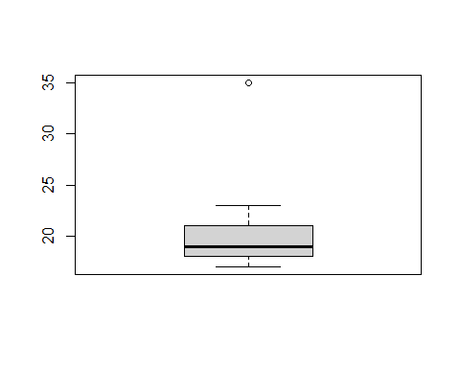

barplot(table(base $Sexe), main = "Diagramme à barres", xlab = "Sexe", ylab = "fréquence", args.legend = c("M","F"), col = "red") #diagramme en bande

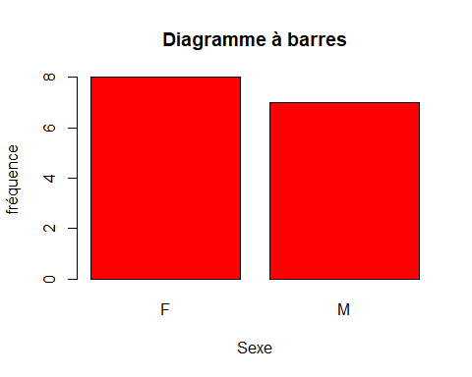

hist(base $Age, main = "Histogramme de l'age", xlab = "age", ylab = "fréquence", col = "orange")#histogramme

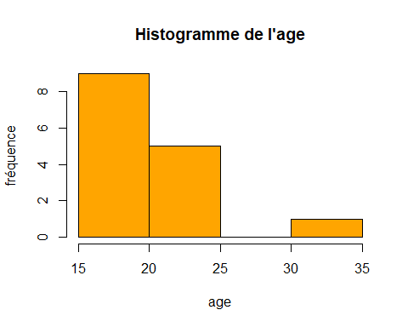

pie(table(base $Taille)) #Diagramme circulaire

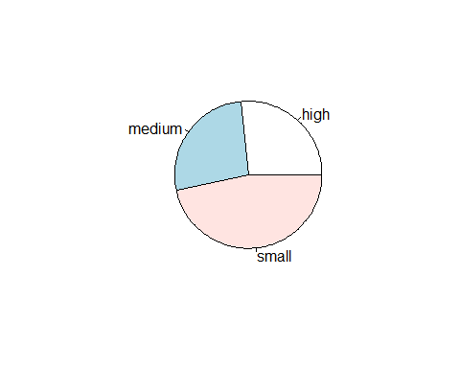

#example(pie)  
barplot(table(base $Sexe, base $Taille), main = "Taille de vetements", xlab = "Taille tee-shrit", ylab = "Fréquence", names.arg = c("high","medium","small"), beside = TRUE, col = c("darkblue","red"), legend = row.names(table(base $Sexe, base $Taille)))

